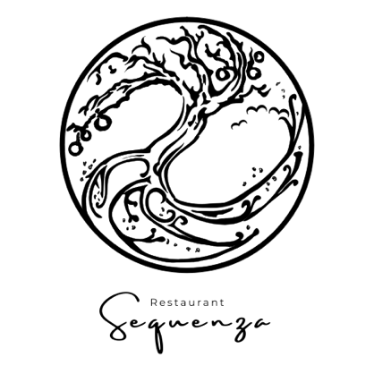

Northsea Crab
Gasconne beef | Tarragon | Macadamia
~

Kingfish**
Calamansi | Courgette | Peanut
~

Skrei
Porcini mushroom | Jerusalem artichoke | Nashi pear
~

Guinea Fowl*
Potato | Tamarind | Massaman
~

Sirloin Steak
Umeboshi | Red Cabbage | Lemongrass
~

Blood Orange
Praline | Rosemary | Dutch vanilla

Four courses | €59,- | ~~ | All-in | €110,-
Five courses* | €69,- | ~~ | All-in | €125,-
Six courses** | €79,- | ~~ | All-in | €140,-
Supplement signature dish | €18,- | ~~ | incl. wine | €26,50
Sweetbread (Signature Chef Thales)
Roscoff onion | Guanciale | Madeira
Halibut & Langoustine (Signature Chef Mitchel)
Artichoke | Lavas | Fenugreek

All-in

Sparkling aperitif
Matching wine with each course
Water flat and sparkling
Coffee or tea with friandises

Wine per glass | €8,50
Champagne | €14,-

